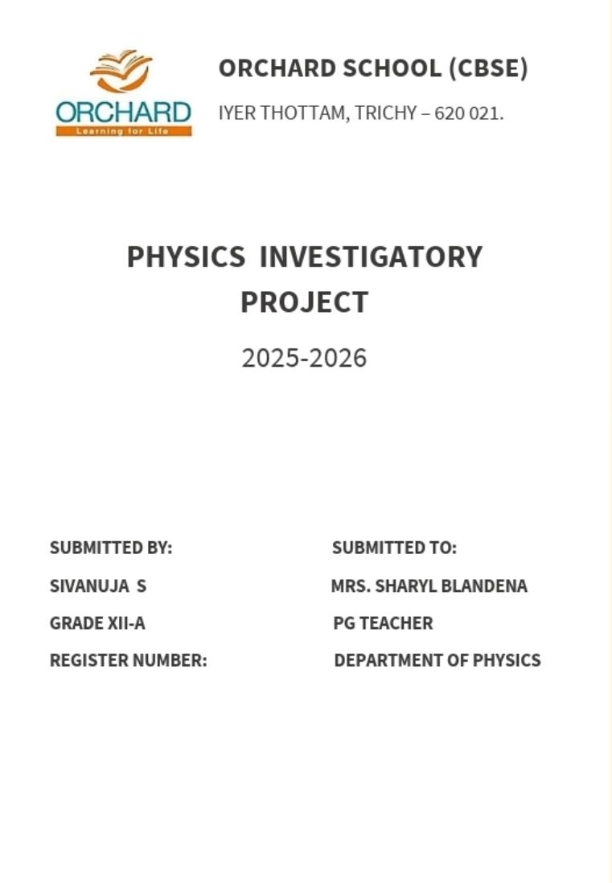
Certificate

This is to certify that, the bonafide record of project work done by SIVANUJA S of Grade 12 during the academic year 2025 – 2026. Submitted for AISSCE Physics Practical Examination held on ___/___/2025 at Orchard School (CBSE), Iyer Thottam, Trichy-21.

Date:

Internal Examiner External Examiner

Principal

Declaration

I hereby declare that the project work entitled, “Charging by Induction: Making a contactless Electroscope”, Submitted to the DEPARTMENT OF PHYSICS, Orchard school is carried out by me. This work has not been submitted earlier in full or in part.

S.Sivanuja

Acknowledgement

I would like to express our special thanks of gratitude to our school principal MRS.SILVIE NESA as well as to our Physics teacher MRS.SHAREL BLANDENA who gave the golden opportunity to do this wonderful project on this topic ‘CHARGING BY INDUCTION: MAKING A CONTACTLESS ELECTROSCOPE.’ which also helped me in a lot of research work and I came to know about so many new things. I am really thankful to them.

Sivanuja S

Index

Serial Number | Topic | Page Number
1 | Introduction | 1
2 | Theory | 2
3 | Apparatus | 3
4 | Experimental Setup | 4
5 | Procedure | 5
6 | Observation | 6
7 | Graph | 7
8 | Conclusion | 8
9 | Precaution | 9
10 | Bibliography | 10

Introduction

Electrostatics is a key area of physics that deals with stationary electric charges. Detecting these charges is essential in understanding their properties and behaviour. An electroscope is a simple device used to detect the presence of electric charges.

This project investigates how a contactless electroscope can be built to detect charges through electrostatic induction, where a charged object influences another object without touching it. The goal is to demonstrate that static electricity can cause the redistribution of charges in a conductor and thus detect the presence of electric charges without physical contact.

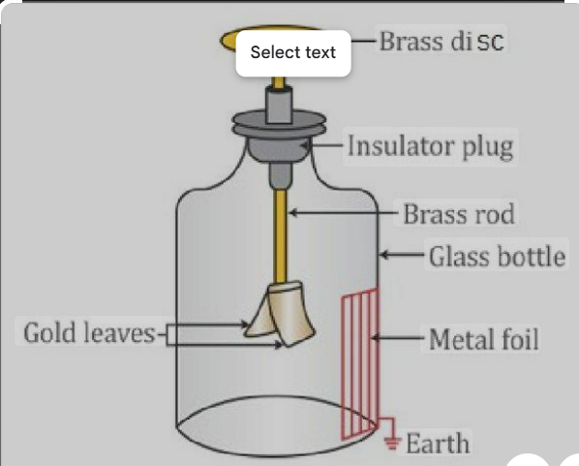

Theory

What is Charging by Induction?
Charging by induction occurs when a charged object is brought near a conductor. This causes free electrons in the conductor to rearrange due to the electrostatic force:
- If the nearby object is negatively charged, electrons in the conductor move away.
- If it is positively charged, electrons in the conductor move toward the object.
This process does not require direct contact.

How does an Electroscope Work?
An electroscope typically consists of :
A metal rod connected to two thin metal leaves (usually aluminium).
- When a charge is present, the leaves receive like charges and repel each other.

Apparatus

- Glass jar or plastic container
- Cardboard or plastic sheet (lid)
- Aluminium foil (for leaves)
- Copper wire or metal paper clip
- Adhesive tape or glue
- Charged object (balloon, PVC pipe, or comb)
- Wool or hair (to generate static charge)
- Ruler
- Scissors
- Protractor (for measuring leaf divergence angle)

Experimental Setup

1.Construct the Electroscope:
  - Cut two strips of aluminium foil (~2–3 cm each).
  - Straighten a paper clip and attach the strips at the bottom.
  - Insert the paper clip vertically through the centre of a cardboard lid.
  - Create a ball or loop at the top of the paper clip using aluminium foil.
  - Place the lid on the jar so the leaves hang freely inside.

2.Prepare for Charging:
  - Use a balloon or PVC pipe and charge it by rubbing it with wool.

Procedure

- Set up the electroscope on a flat surface away from wind.
- Rub the balloon or PVC pipe with wool/hair to build up a static charge.
- Bring the charged object close (without touching) to the metal ball on the electroscope.
- Observe the movement/divergence of the aluminium foil leaves.
- Record the distance of the charged object and the angle of leaf divergence using a protractor.
- Repeat the experiment with varying distances and different charged materials.

Observation

Trial | Charged Object | Distance from Electroscope | Leaf Divergence | Observations
1 | Balloon | 2 | 25° | Moderate divergence
2 | PVC Pipe | 1 | 40° | Strong divergence
3 | Plastic comb | 3 | 15° | Slight divergence
4 | No charge | 1 | 0° | No divergence

Conclusion

The experiment confirms that:

- A charged object can induce a charge in a conductor without direct contact.
- The leaf divergence increases as the charged object gets closer.
- Electrostatic induction can be effectively used to build a contactless electroscope.
- This method is useful for demonstrating static electricity and charge behaviour in insulating and conducting materials.

Precautions

- Ensure the foil leaves are identical in size and weight.
- Keep the electroscope away from fans, wind, or drafts.
- Avoid touching the metal parts during experiments to prevent accidental grounding.
- Handle aluminium foil carefully to avoid tearing.
- Repeat trials to ensure accuracy and consistency.

Bibliography

- NCERT Physics Textbook – Class12
(Electrostatics)
- Resnick, Halliday & Walker – Fundamentals of Physics
- HyperPhysics – http://hyperphysics.phy-astr.gsu.edu/
- Khan Academy – Electrostatics
- BYJU’S Learning App – Static Electricity Concepts
- Science Buddies – "Make an Electroscope

Thank You

